NPTEL:

Emergence: Self-Organization is a process by which system increases its complexity through internal organization without being guided by any external source.

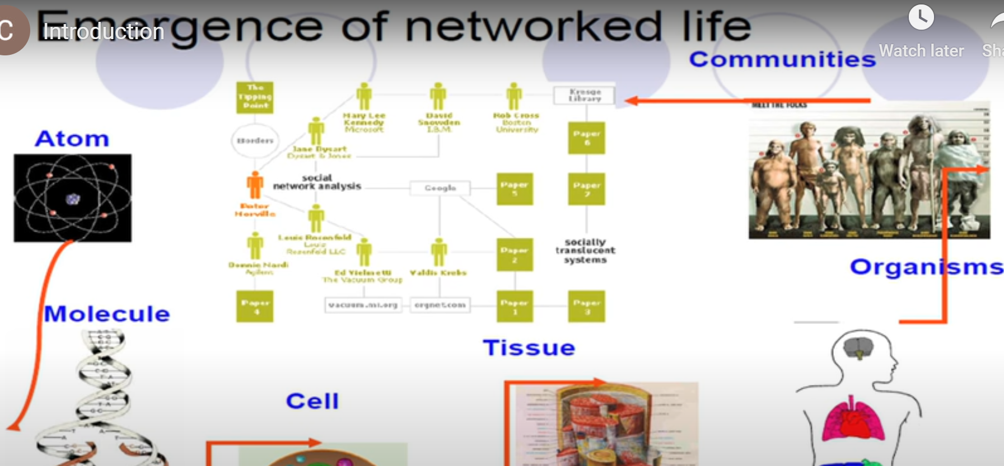

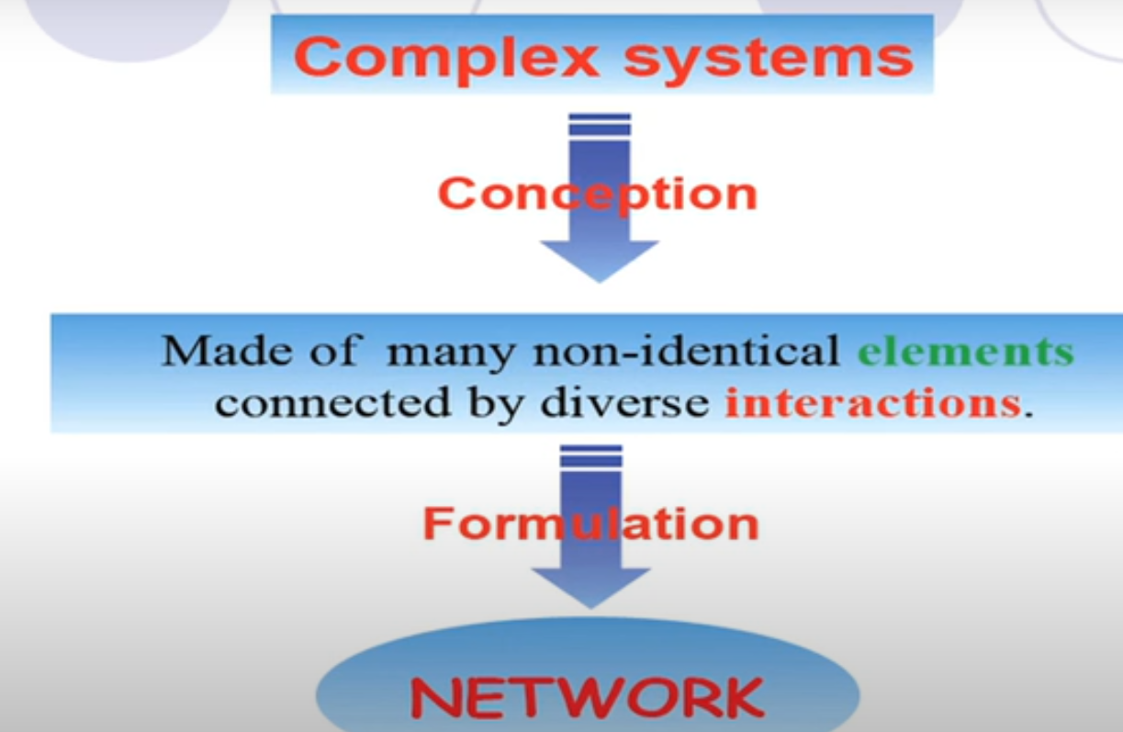

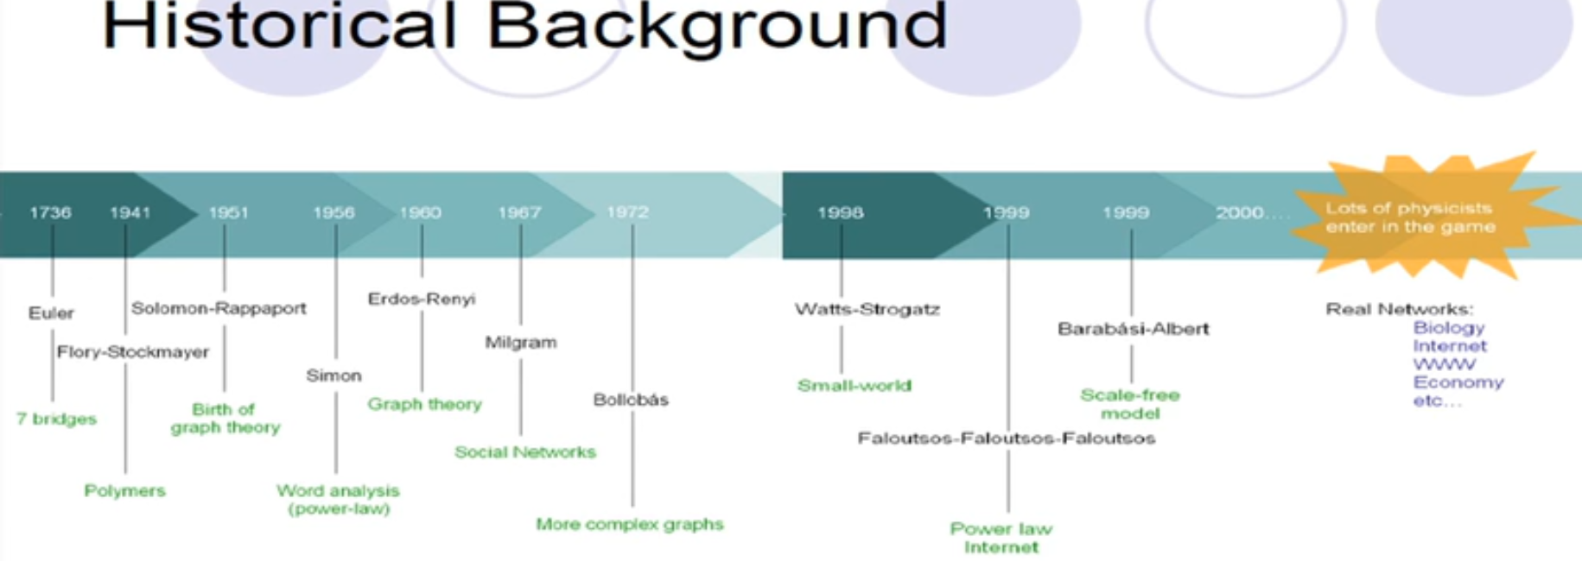

Reason for modeling complex systems is:

1. **Why are we doing network formulations?** -- Structural arrangement that has gone into the network. Quantitate metrics that illustrates this point.
2. **Dynamicity:** That means theses system are not static. They change over time. New nodes entering into the system and edges, are formed and these actually makes the system dynamic. This dynamicity in the form of network where the dynamicity of particular page entering can be modeled as node entering into the network and the dynamicity of new edges getting included in the network can be modeled as new hyperlink being built.

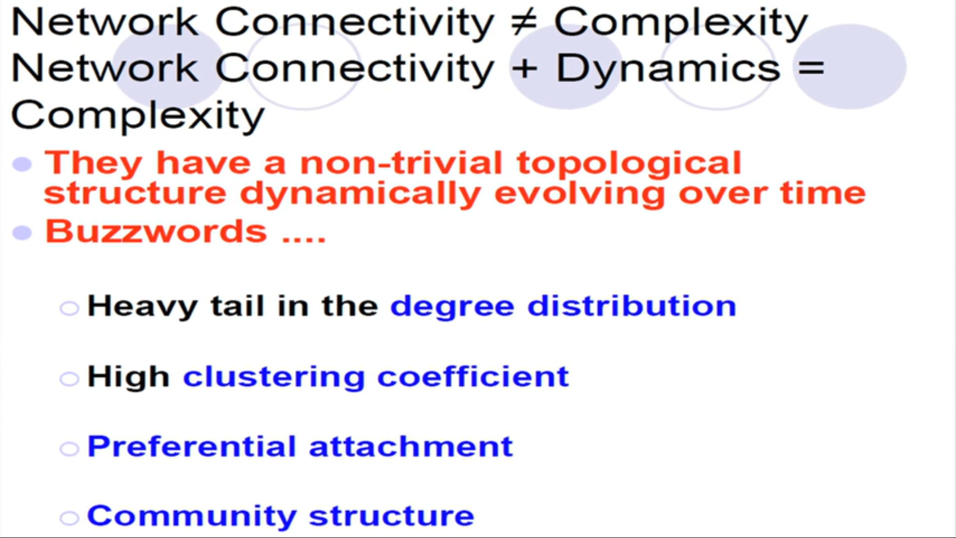

Example of complex networks:

1. Citation: Scientific papers--> refer to another scientific paper. (papers are nodes)(directed)

Edges only point backward in time.

P1 --> P2 --> P3.

Therefore acyclic

1. Collaboration network--> Two scientists are connected if they collaborate/ coauthored on a paper. Similar tops form clusters.

**Social network analysis is mathematical methodology for connecting the dots.**

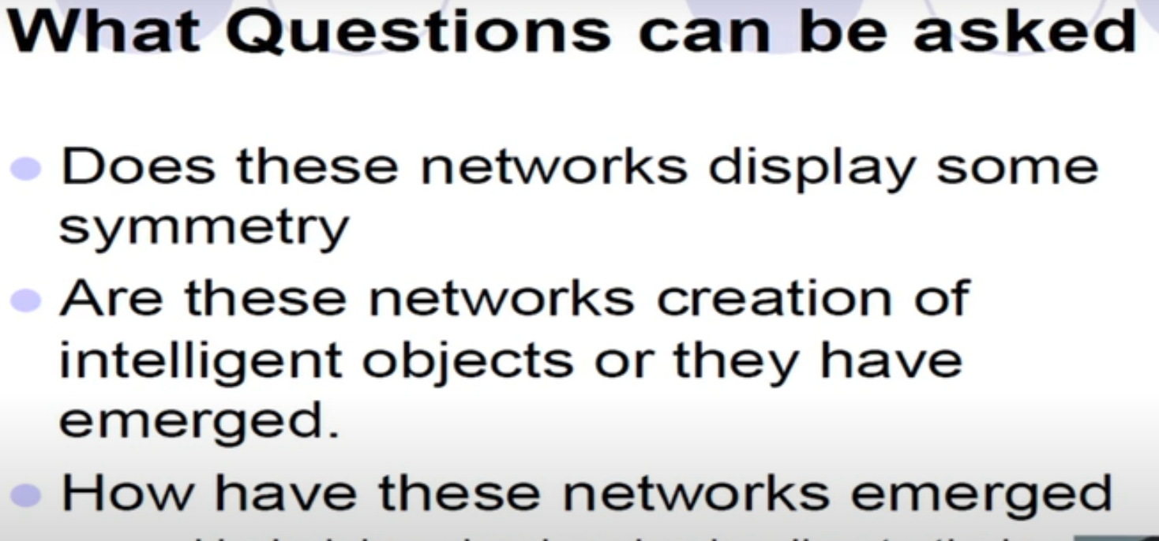

**ANALYSIS-1**

**Metrics- Degree Distribution**

**Case: Citation Network.**

Refers to work done earlier on the same or related topics

When this construction was made there was a famous scientist “Alfred Lokta”

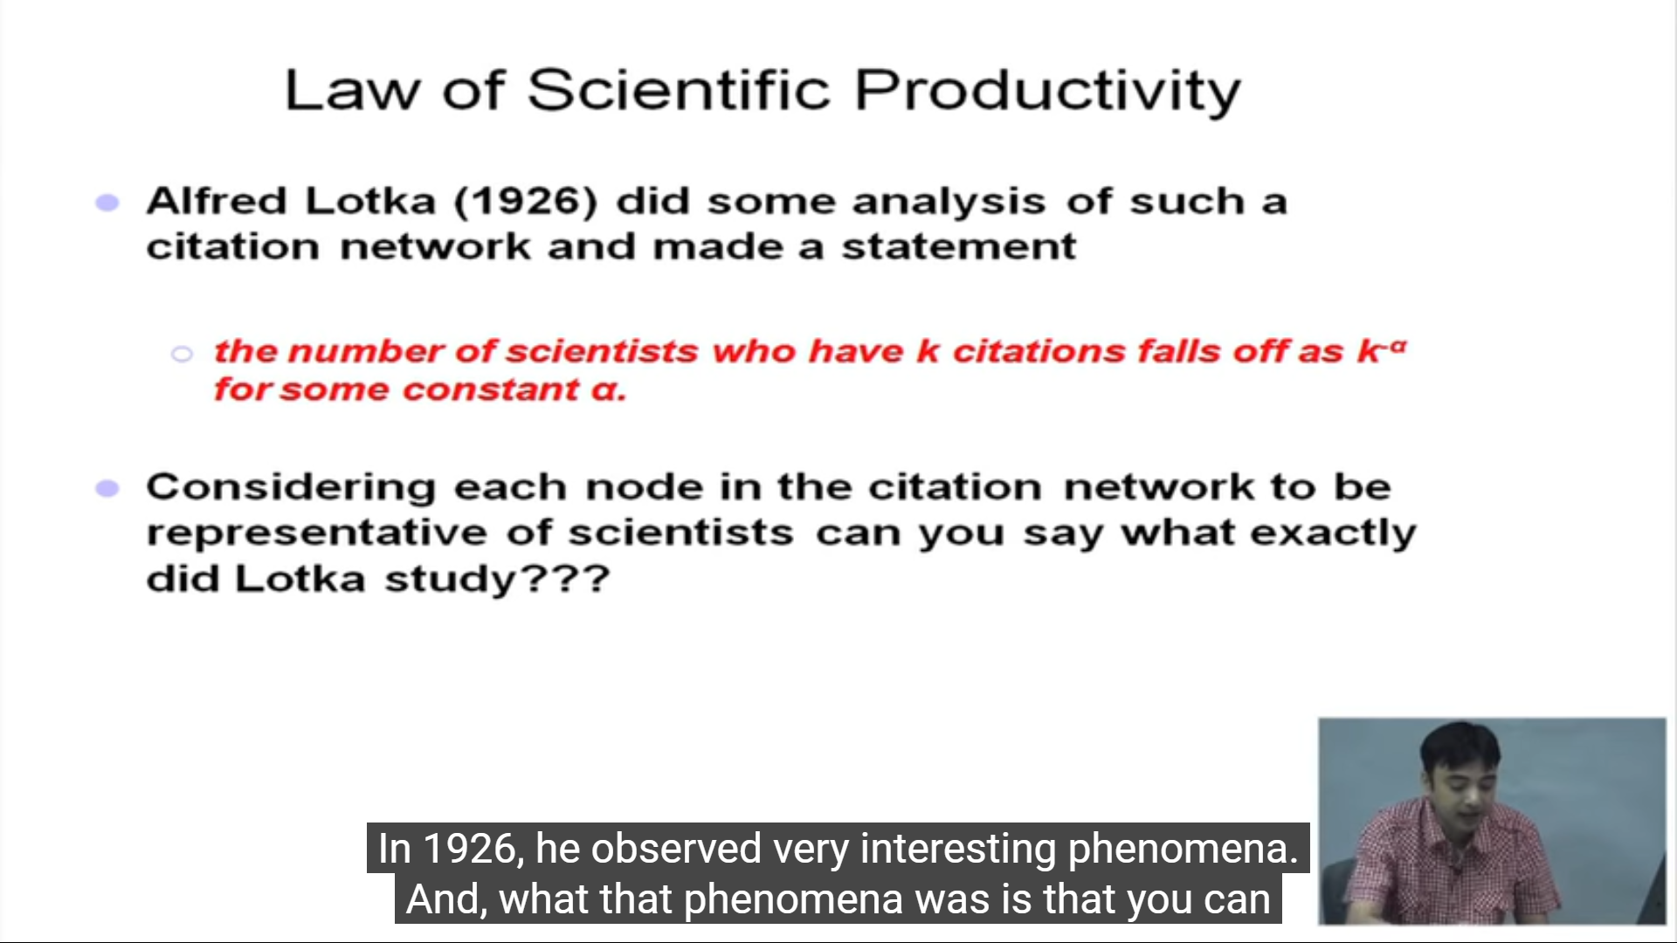

**The distribution of the degree of the nodes.**

The number of papers that have k-citation (in-degree) dacays as K^gama

Gamma is a constant

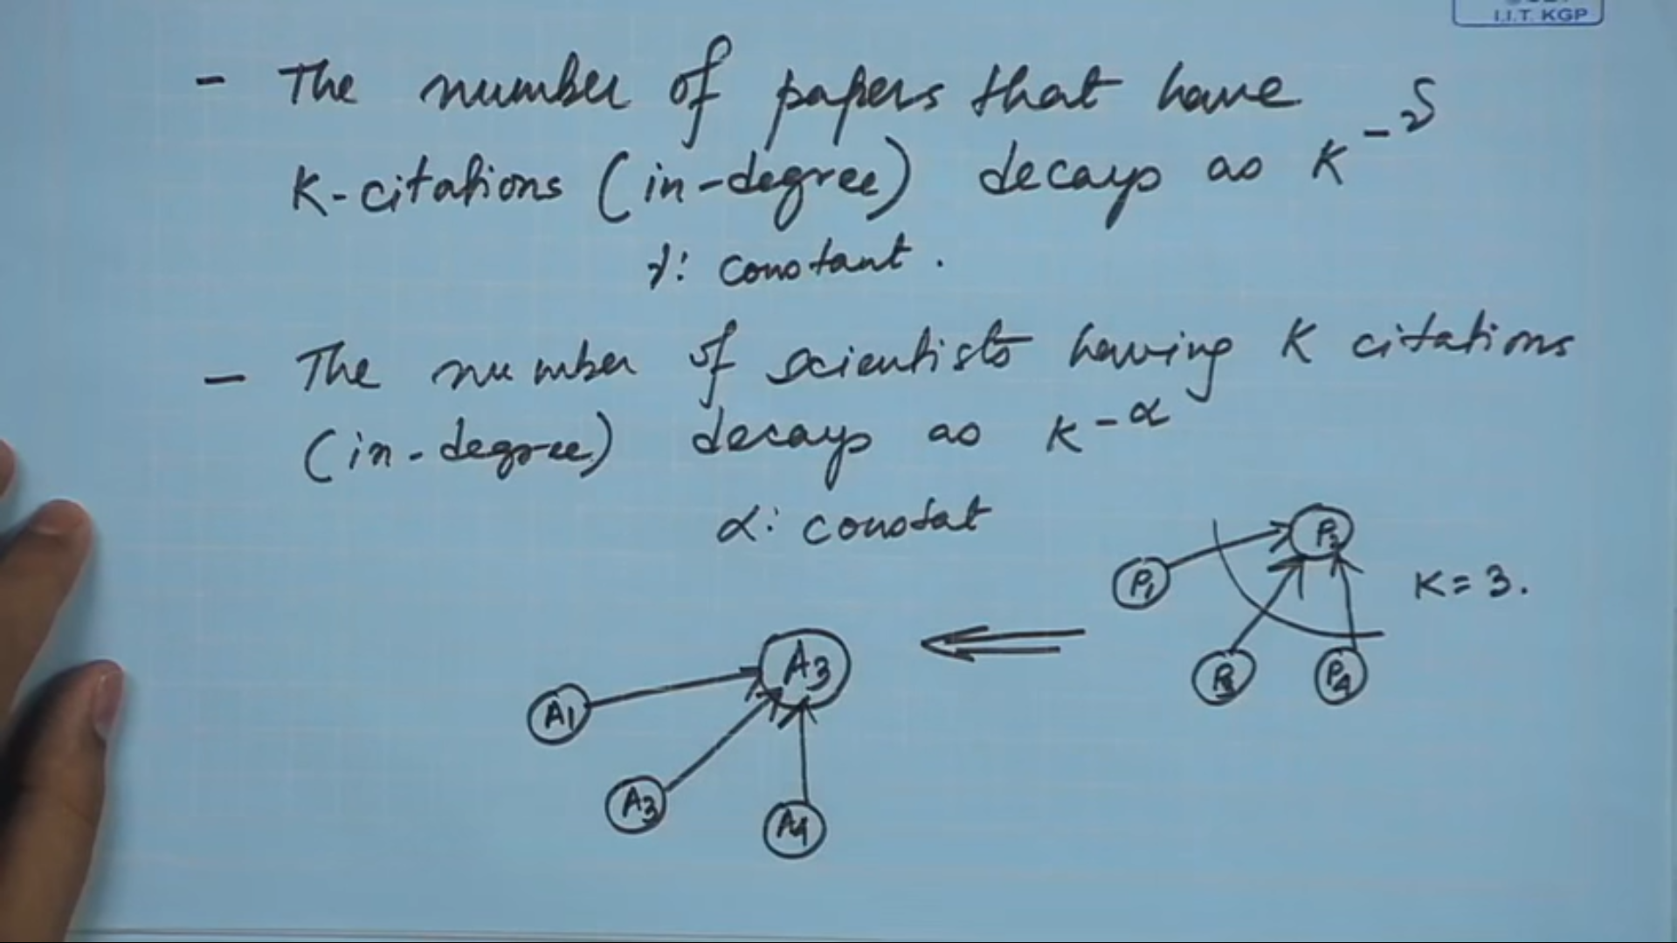

Fraction or number of nodes in the network that have degree K that is degree distribution. This fraction decays as K^-alpha

Degree Vs Fraction of nodes having that particular degree, this follows a decaying behavior.

This decaying behavior == “Power law” behavior. (alpha is constant power) Therefore Power law degree distribution.

Why they are interesting behaviour? Because they are scale-free in nature.

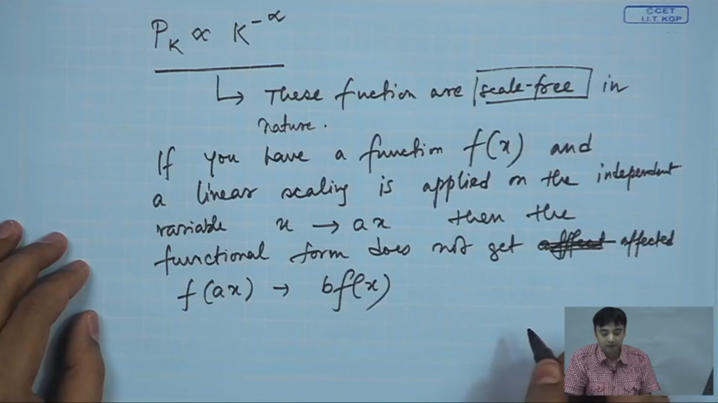

Proof:

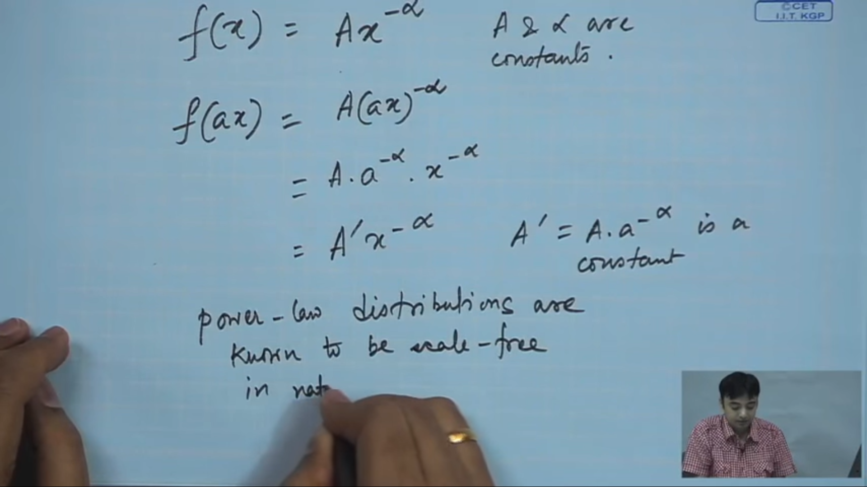

**Self-similar Structures**

Assume a network and remove the peripheral nodes --> Power law distribution and repeat this process again will get power law distribution. Core--> loser core--> less loser core etc.,

NOTE: If degree distributions are not following the same pattern, then the data is not true representative of the population.

Undirected graphs are symmetric

**ANALYSIS-2**

**Clustering Coefficient (Vertex centric measure)**

Comes from the transitivity property of a particular the network.

**Transitivity property:**

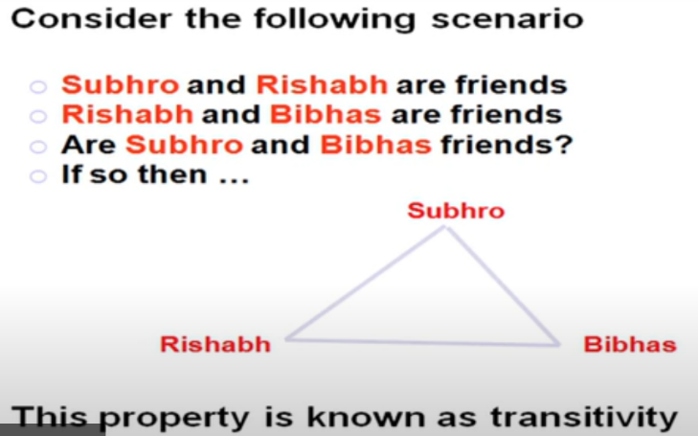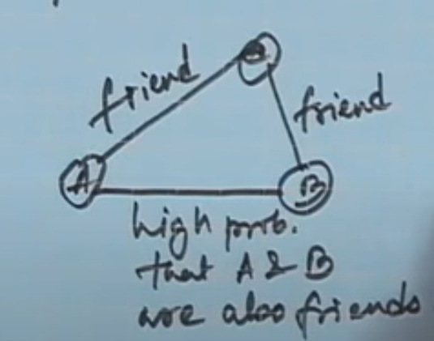

This property can be quantified using Clustering coefficient.

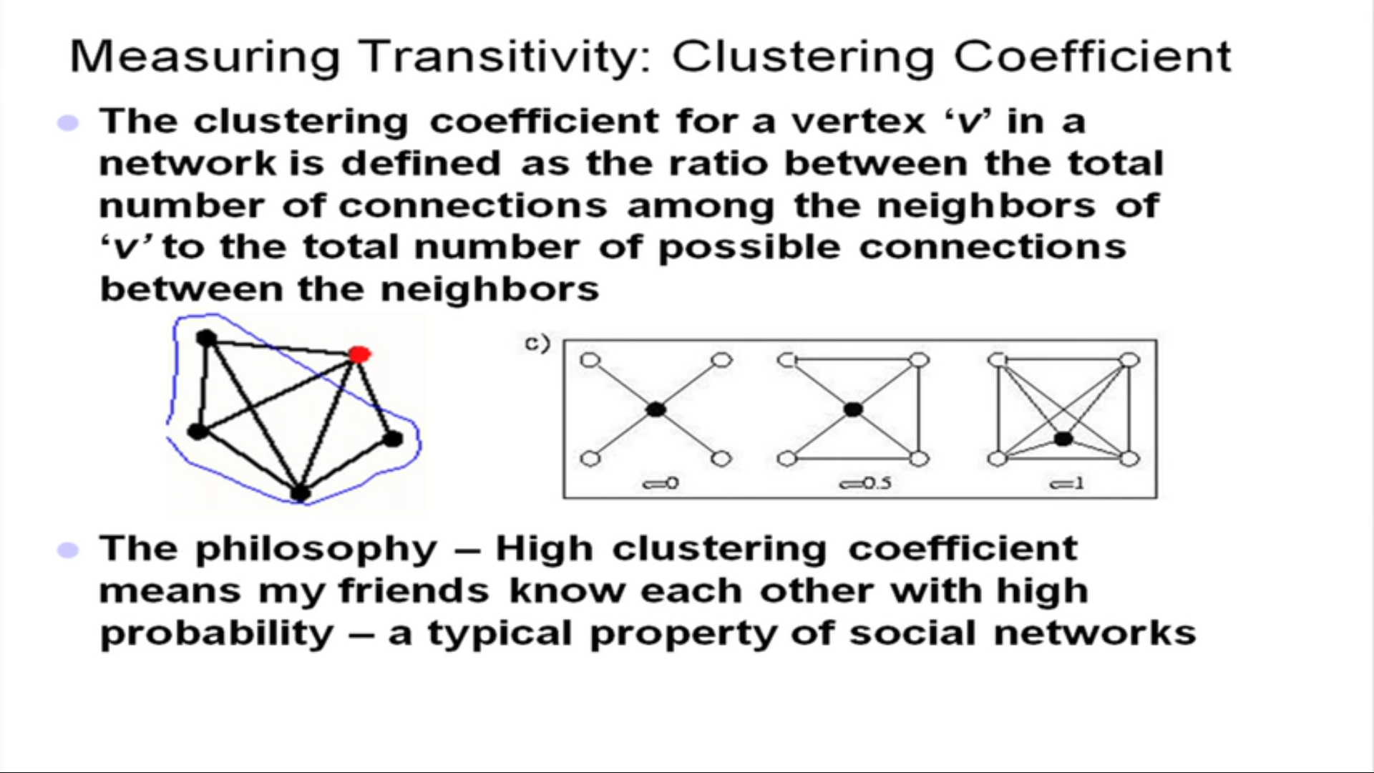

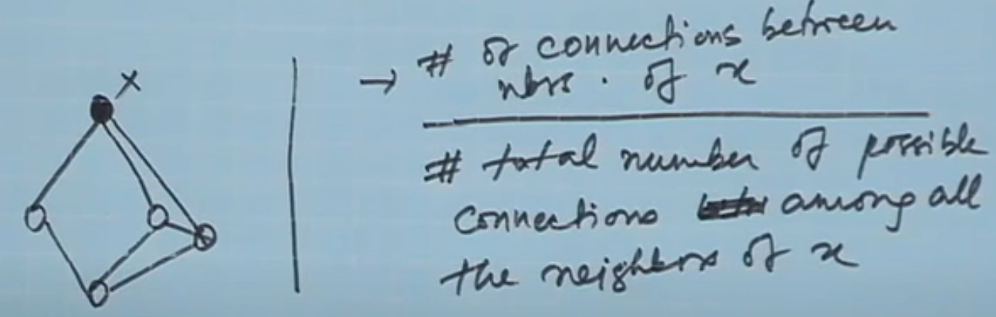 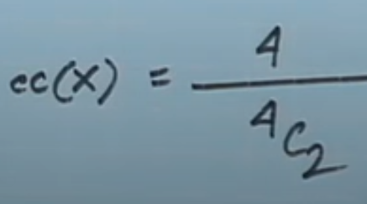

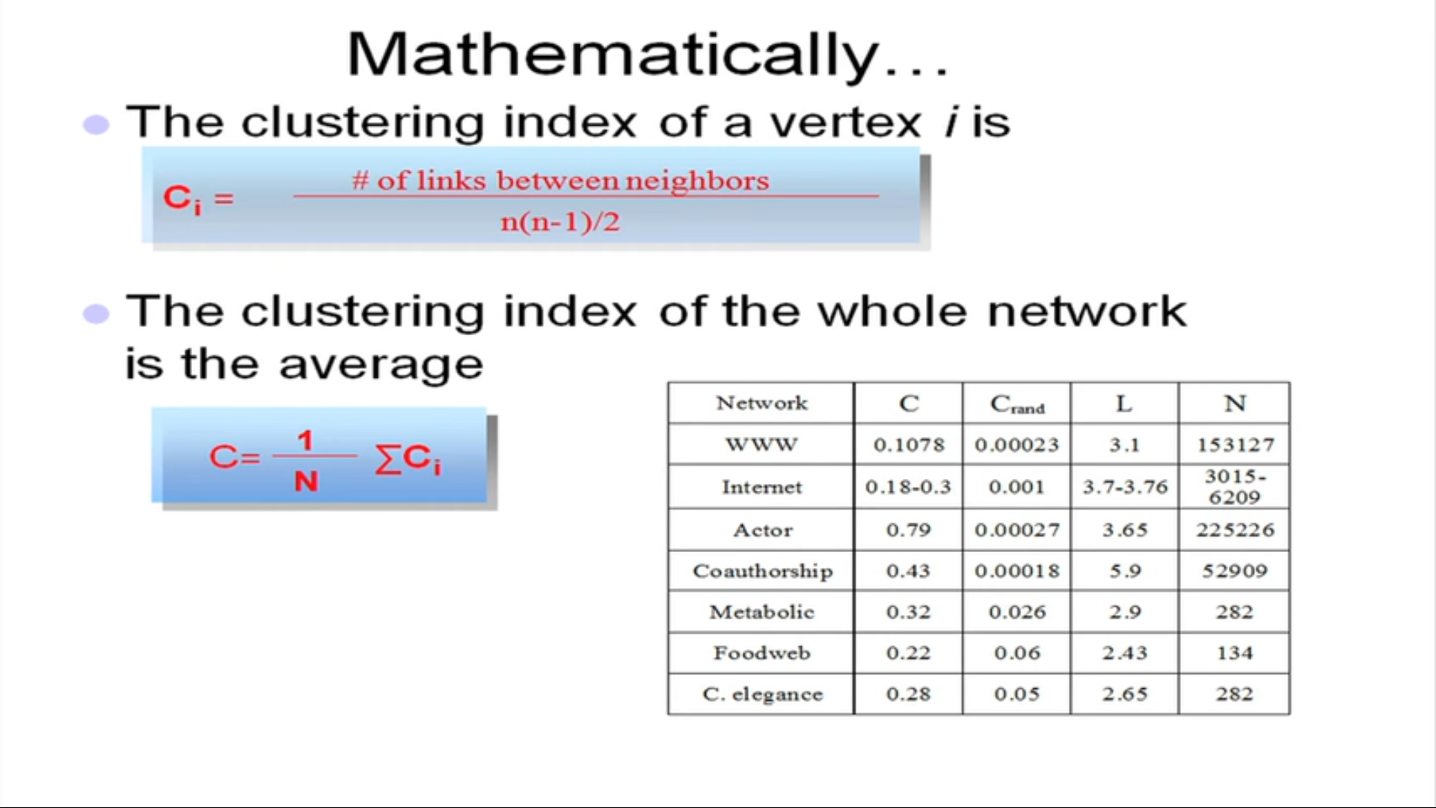

If there are lot of mutual co-authors between a pair of scientists, then it is highly likely that those two scientists have also coauthored a paper. That probability is high in Co-authorship.

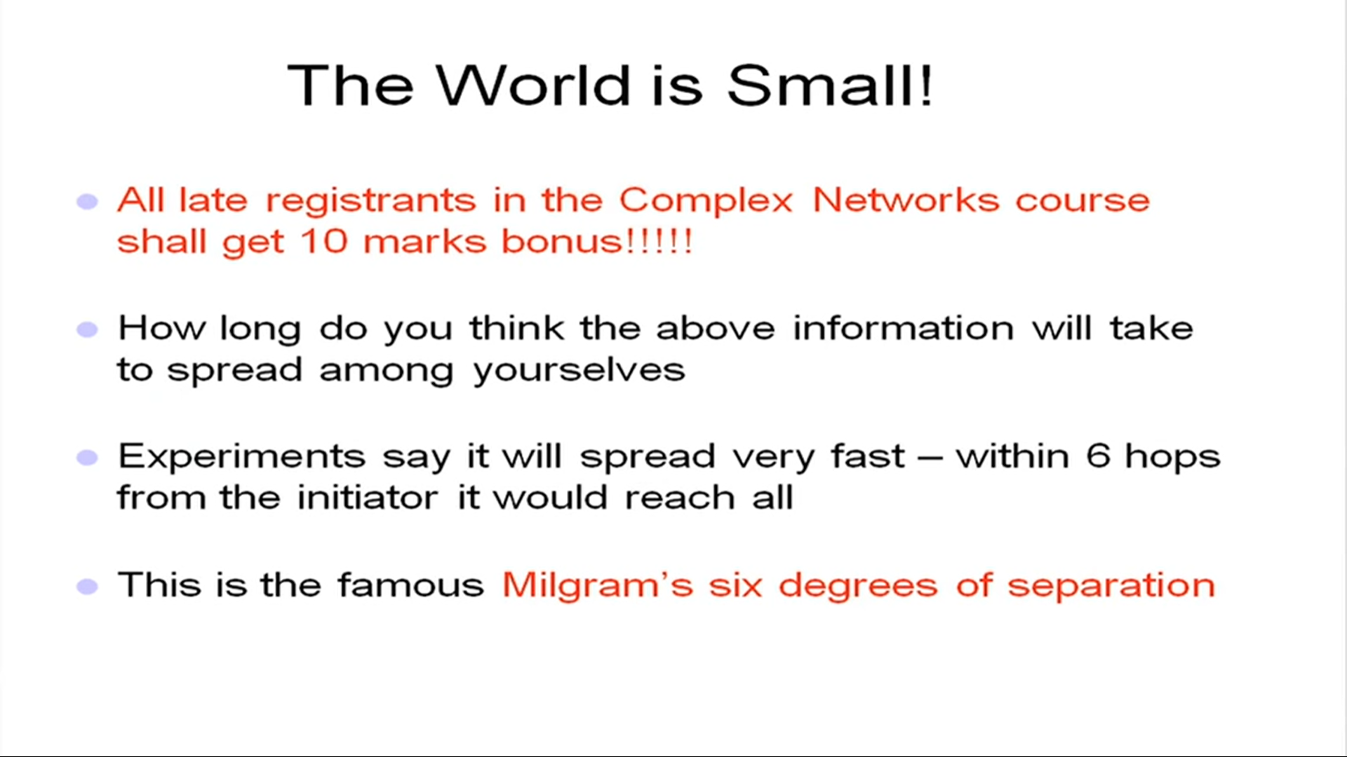

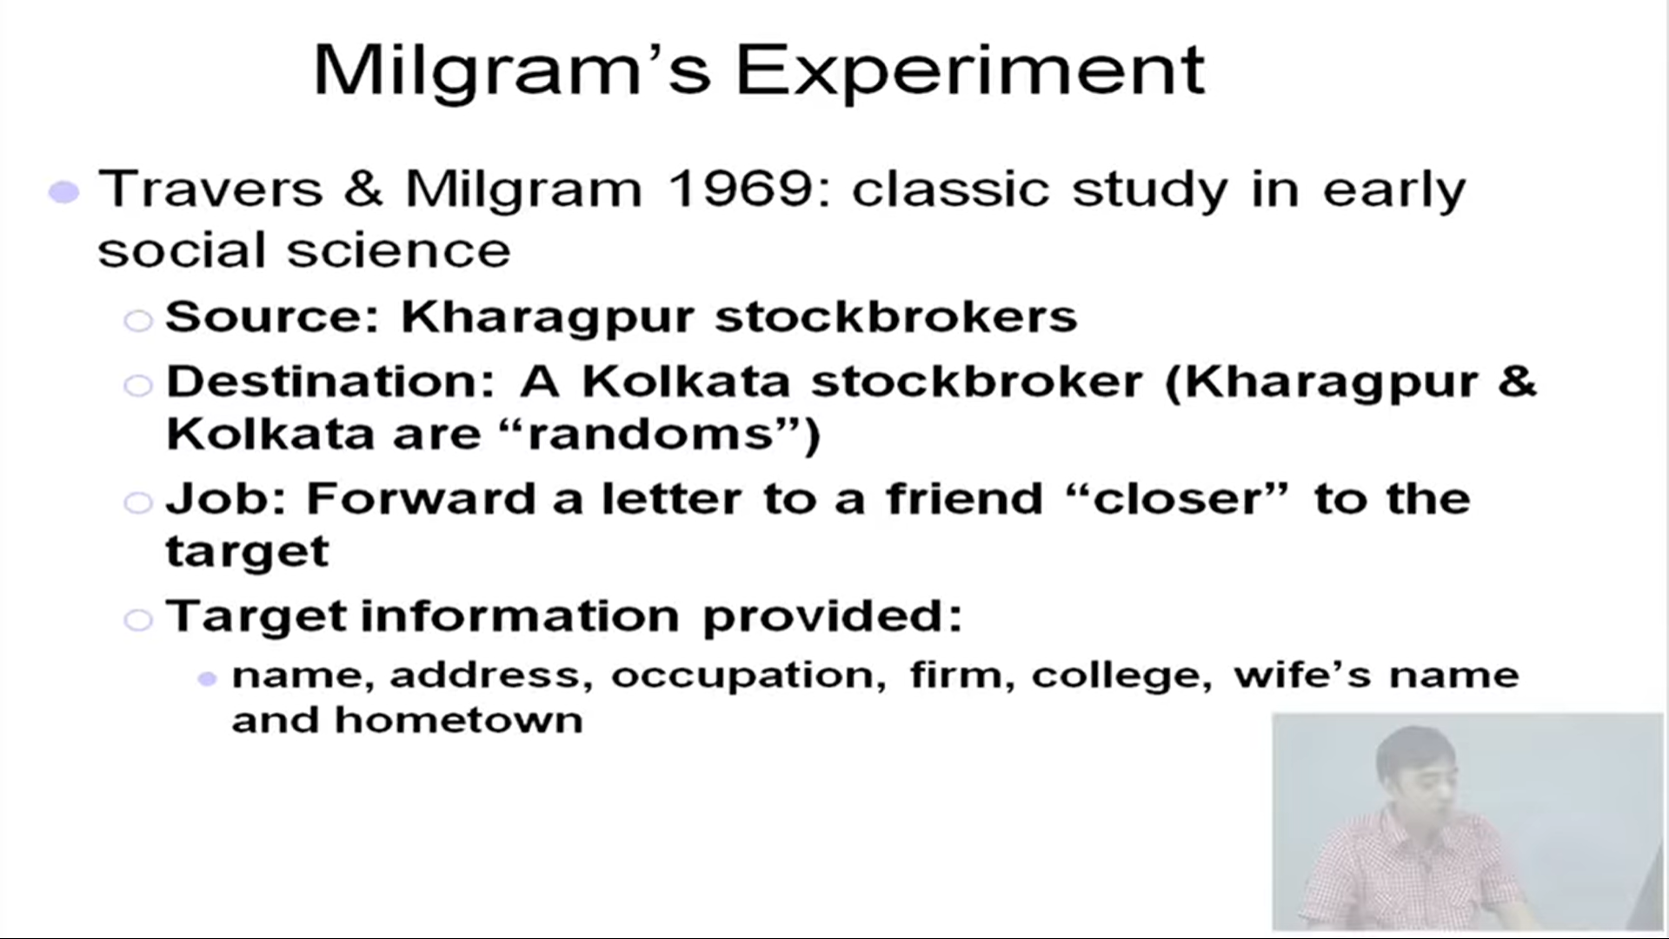

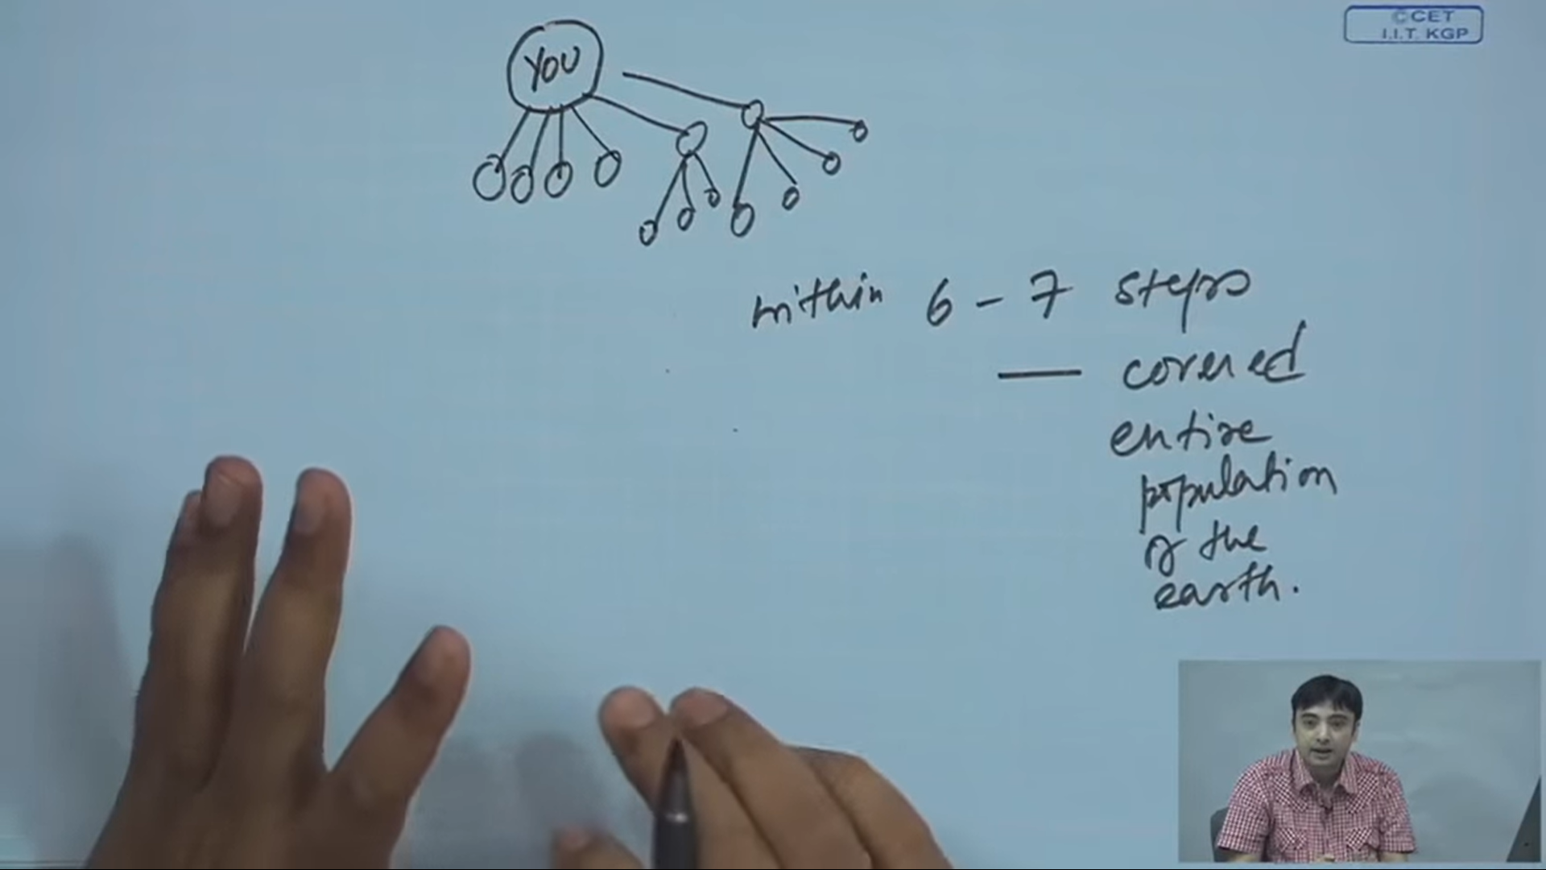

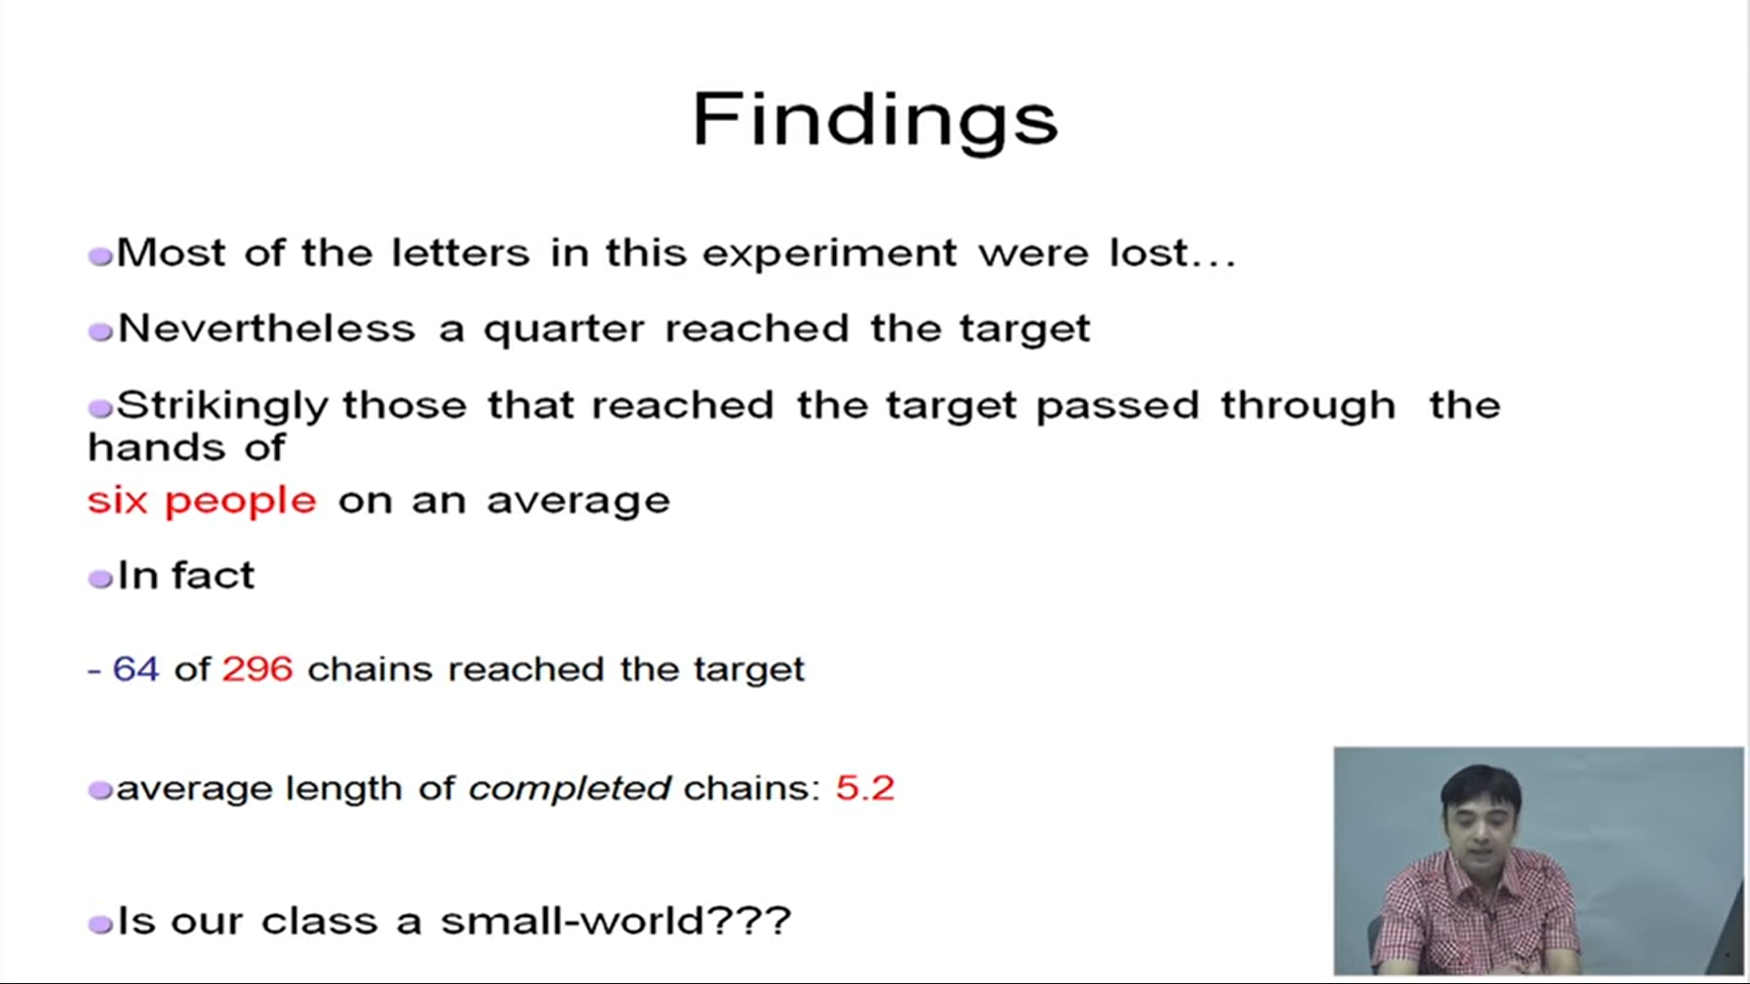

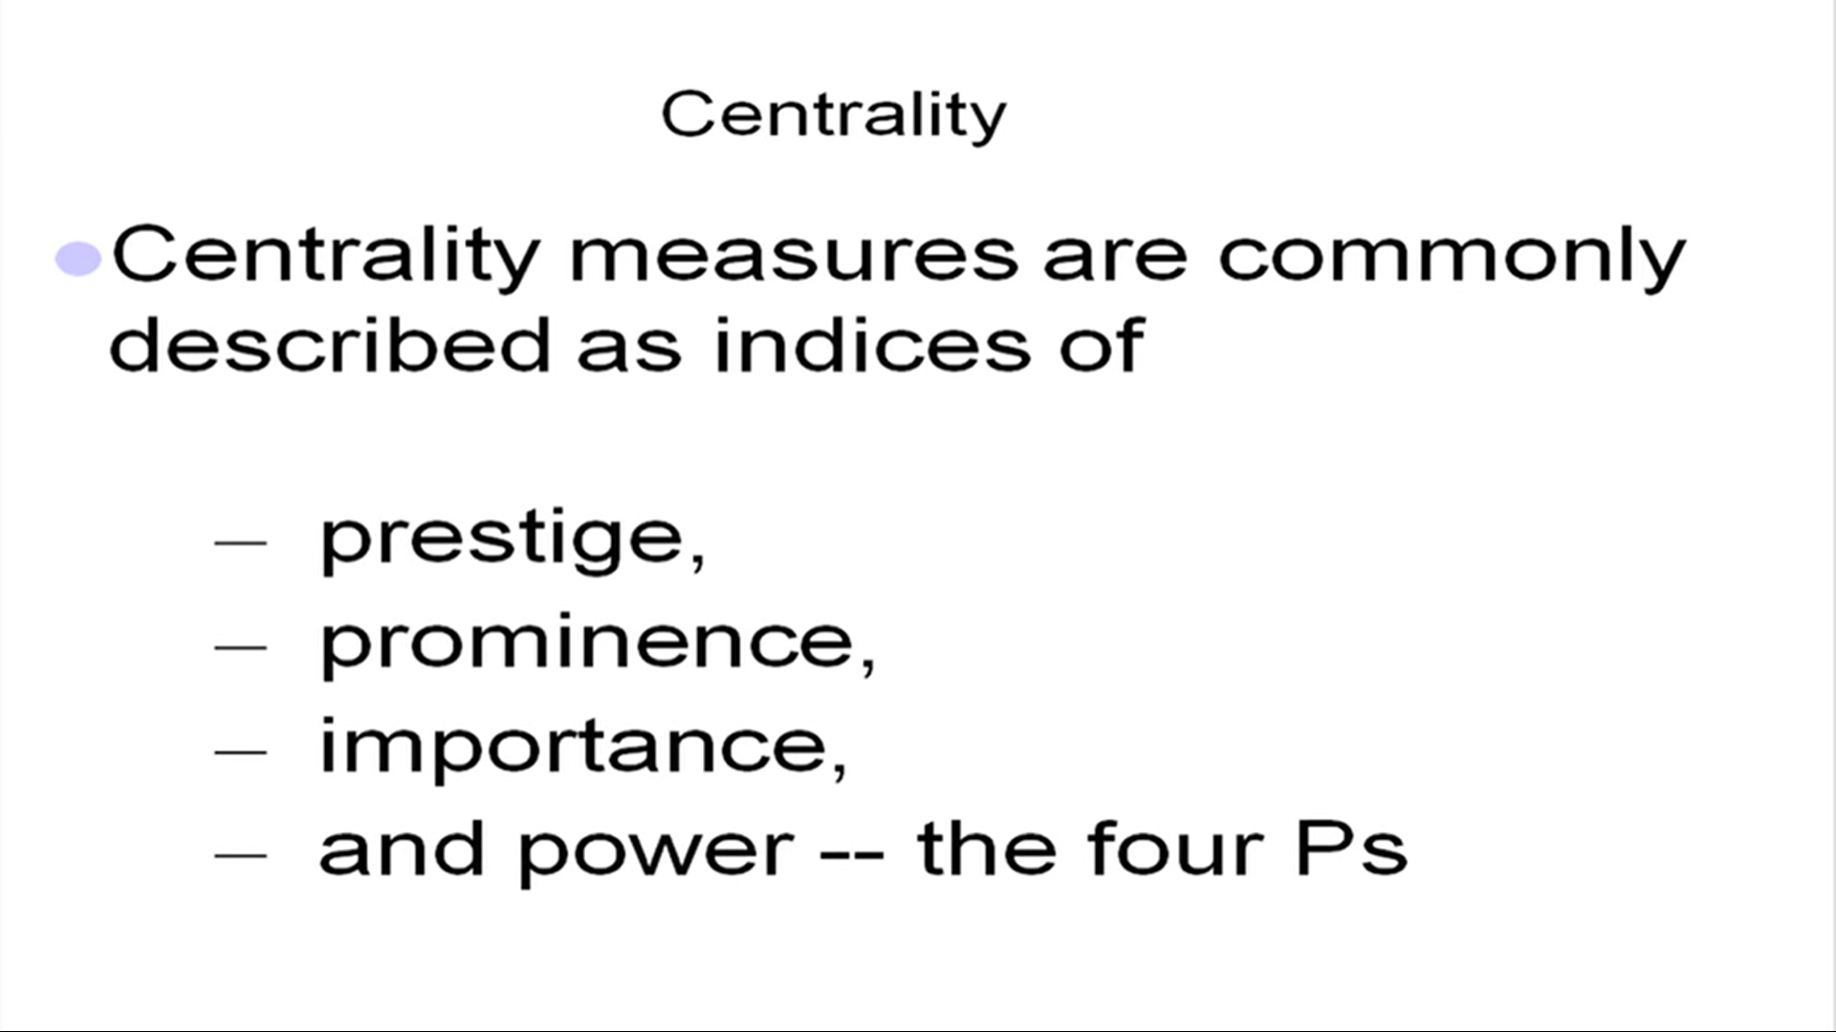

These metrics are important in ranking experiments.

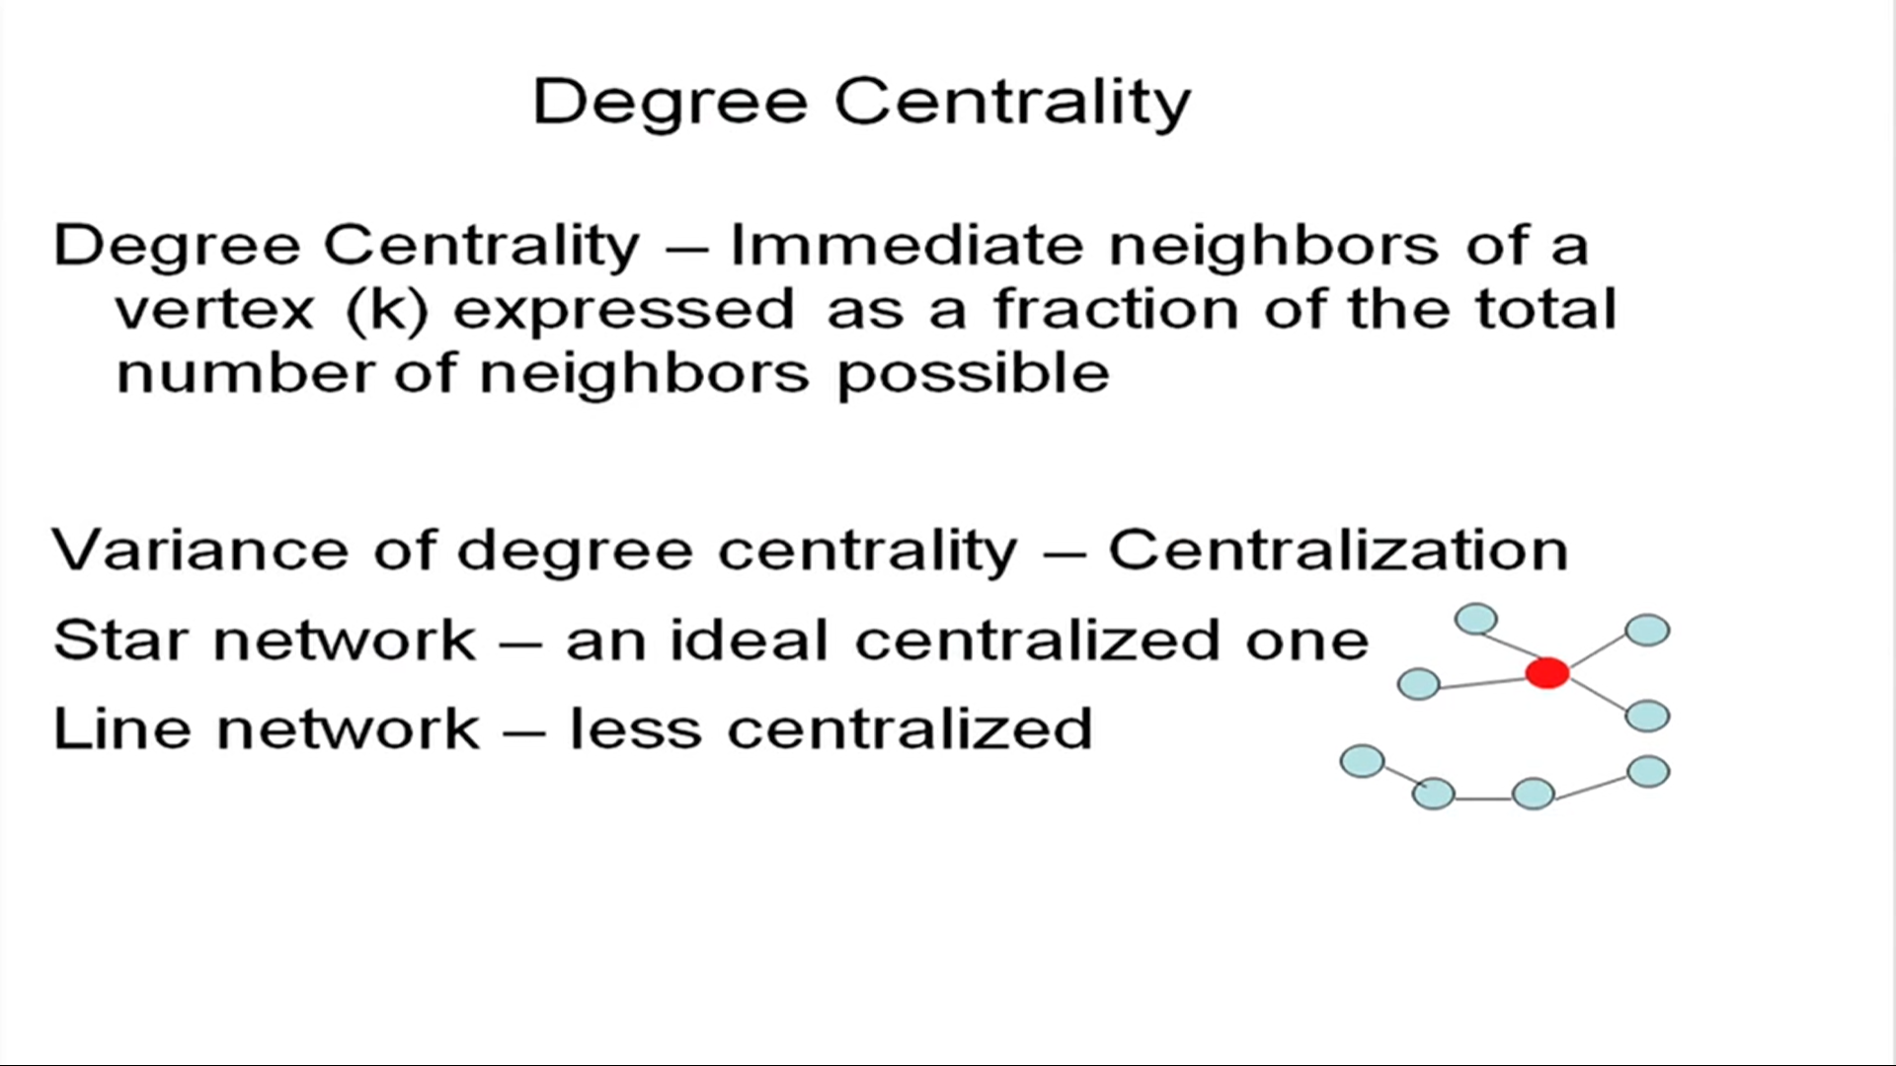

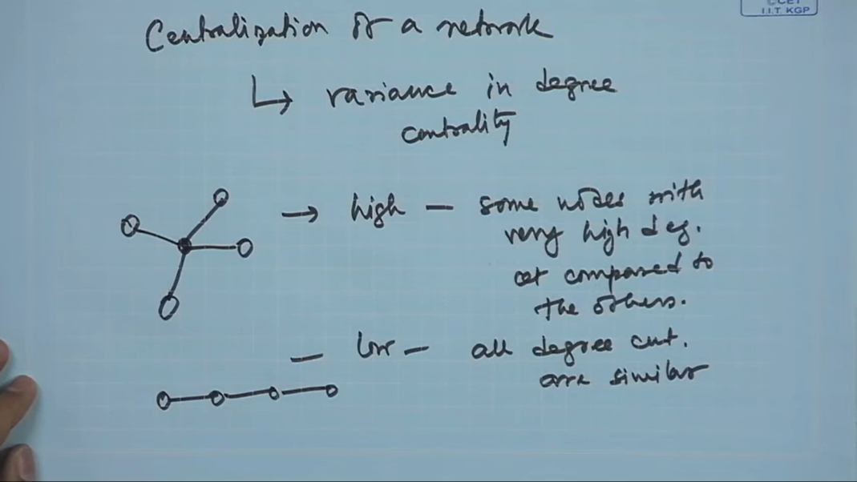

Black node will have high centralization whereas line nodes will have low centralization.

**ANALYSIS-3**

**Degree centrality is not the only way to indicate the importance of the node in a network.**

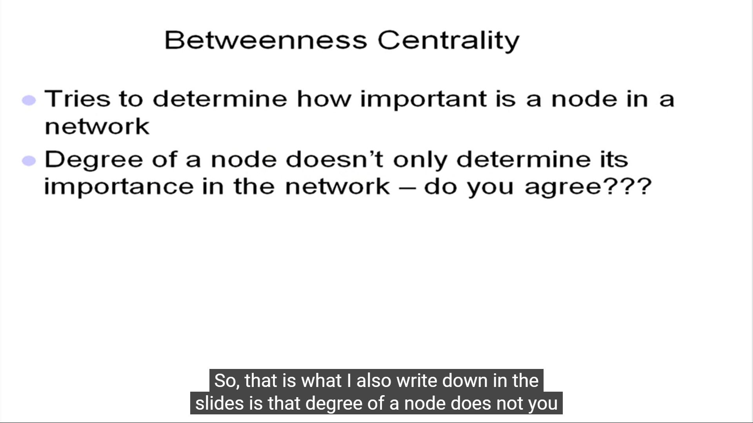

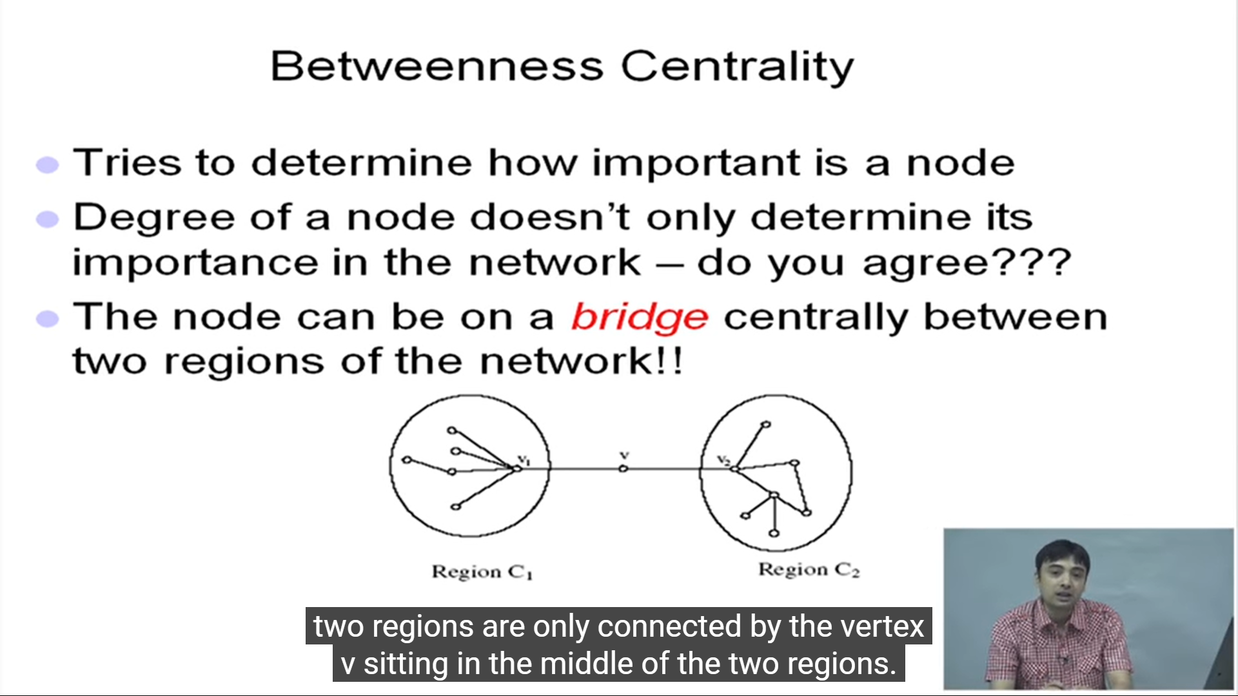

V acts as bridge between two different regions of the network. These nodes are very important because if you want to pass information from region C1 to C2, you have to rely on node V no other way. However, how to quantify the presence of such nodes in the network and that brings us to **“Betweenness centrality”** of the nodes in a network.

The number of shortest paths passing between any pair of points through V is the property that differentiate these nodes. If this is very high wrt to the total number of shortest paths pass between the points. This illustrates that the node is acting like a bridge. Geodestic distance is also called **shortest path.**

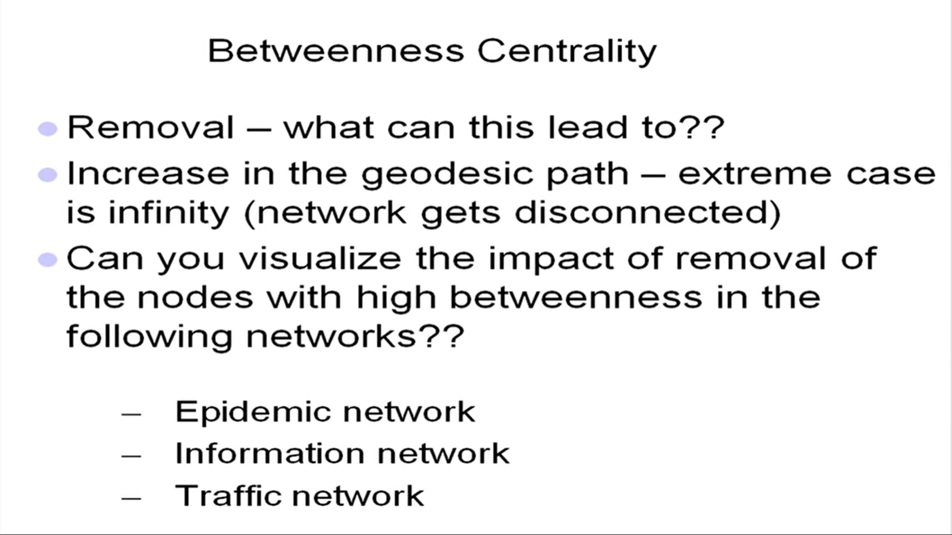

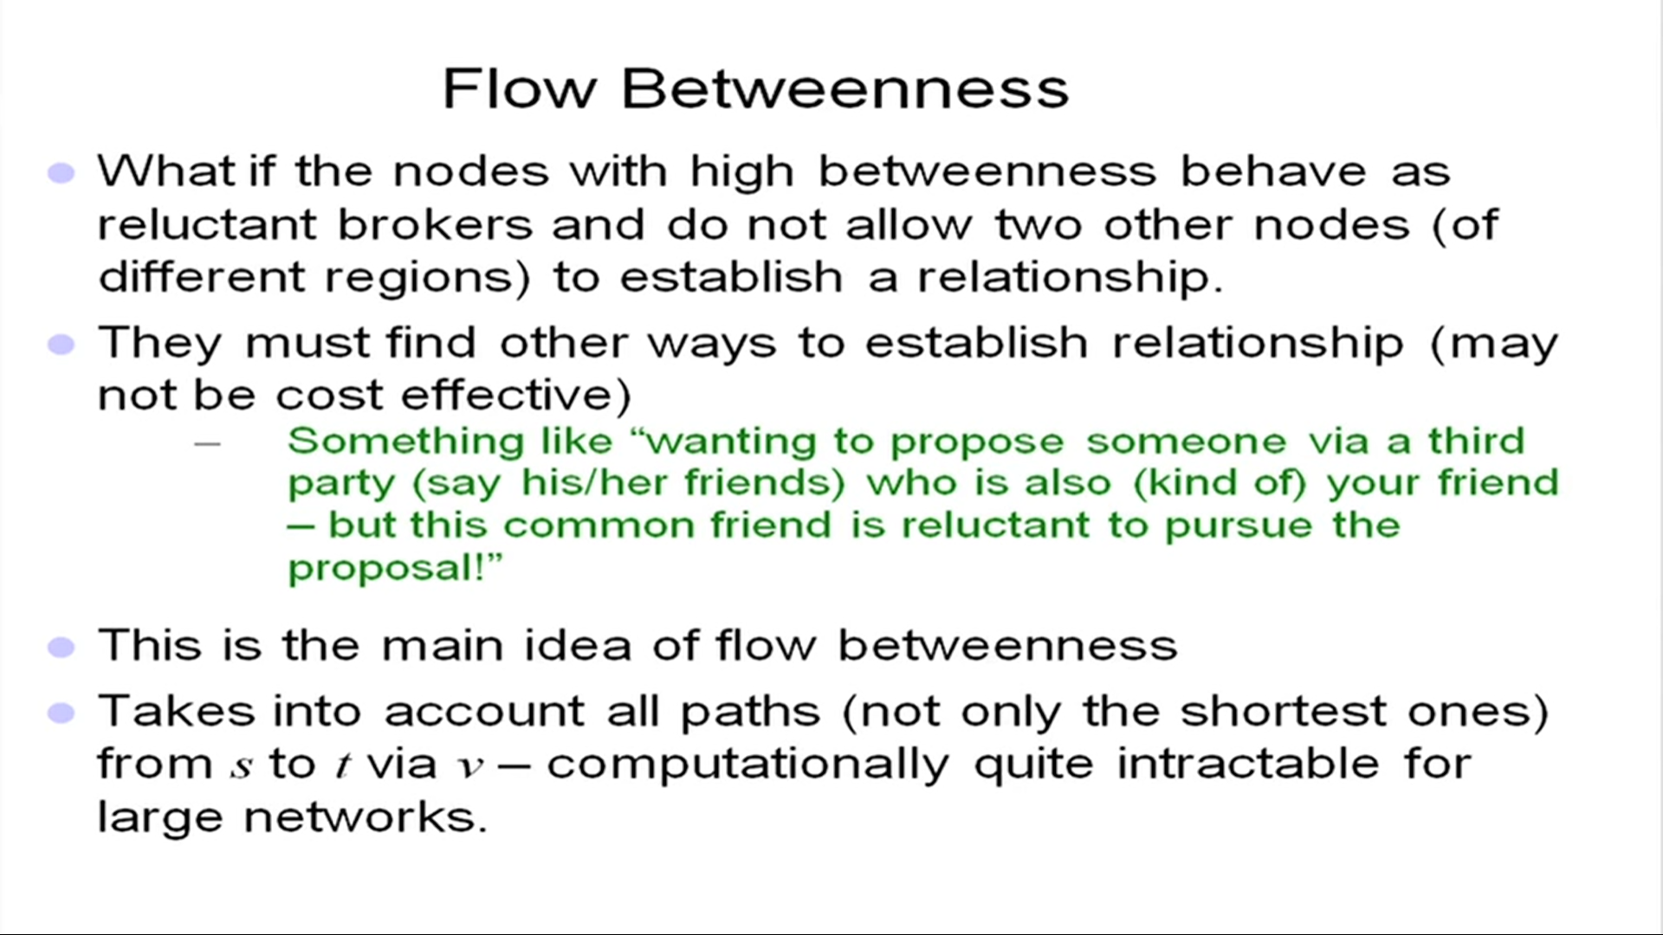

**Eigenvector Centrality** (Recursive Definition of Centrality):

Popularity of a node depends on the popularity of the neighbor nodes and this goes on.